User Manual

SkillCourt Backend

Florida International University

Senior Project 2015

Copyright © by Florida International University – Senior Project – SkillCourt Backend

All rights reserved. No part of the SkillCourt Backend Project may be reproduced or transmitted in any form or by any means without prior written consent.

Table of Contents

[1. Introduction 3](#_Toc418154312)

[2. Hardware and Software Requirements 4](#_Toc418154313)

[**2.1.** **Hardware Requirements** 4](#_Toc418154314)

[**2.2.** **Software requirements** 4](#_Toc418154315)

[3. Installation and Setup 5](#_Toc418154316)

[4. Getting Started 7](#_Toc418154317)

[**4.1.** **Creating a new Account:** 7](#_Toc418154318)

[**4.2.** **Enter as a guest:** 9](#_Toc418154319)

[**4.3.** **Logging In:** 10](#_Toc418154320)

[**4.4.** **Logging Out:** 12](#_Toc418154321)

[**4.5.** **Routine Selection:** 13](#_Toc418154322)

[**4.6.** **Access Performance Statistics:** 14](#_Toc418154323)

[5. Quick Reference 15](#_Toc418154324)

[6. Accessing Online Help 16](#_Toc418154325)

[7. References 17](#_Toc418154326)

## **Introduction**

Traditionally, the way in which a soccer player trains is by interacting with teammates, the coach, and the ball in a training field. This training, however, depends on others, and the coach cannot assess all players at the same time, therefore, performance reviews are not complete. Additionally, for games like Soccer that require a big field, the availability of space is crucial to training, and lack of space to train is a major setback for individual players, as well as lower-budget soccer teams. For these reasons, among others, soccer training can be a very cumbersome feat for the average person to endeavor unaided. Without proper guidance, progression dwindles and a person may not feel obliged to continue.

Additionally, it is essential for players to develop a high body-mind coordination that allows them to move and perform specific techniques without consciously thinking about it. Extensive training is needed to develop such coordination, and brain efficiency.

The SkillCourt System will provide athletes and individual players with the ability to train and improve their skills by interacting with it in a one to one manner. The system allows the user to choose from a set of predefined routines to be played in a SkillCourt Room. The users is given the option of modifying certain aspects of these predefined routines by adjusting the timer and number of rounds conditions. The mobile device serves as the connection between the players and the SkillCourt pads so that the user. However, it can also display the player’s performance statistics in order to visualize progress over time. A SkillCourt website has been created as well, so that the player or a coach can access these performance statistics. In the website, the player will be given the option to share these statistics on Facebook. This will allow the user to share his or her performance with friends so that they can also see the progress of the player. The system also provides coaches with the ability to create custom routines and share them with their players so that based on the performance the coach can modify the dynamics of the training.

In addition to the already mentioned abilities of the system, it also has Bluetooth capabilities. It allows the user to locate nearby SkillCourt pads and connect to them and send the chosen routine via Bluetooth. Since the SkillCourt pads are not build yet, the routine will be played on a simulator which has the ability to represent real physical conditions like force when hitting a SkillCourt pad and time between hits. It also keeps track of the points scored by the player and the accuracy.

For future development, the system should be capable of analyzing collected data in order to provide more useful information to the athletes, including predictions based on their progress and also based on the progress of other athletes who are practicing similar skills using similar routines. The system should also start handling more complicated graph problems which deal with pads that are out of reach of the master pad Bluetooth range. The system should also increment the available routines. The system should also allow multiplying.

## **Hardware and Software Requirements**

### Hardware Requirements

* To run the SkillCourt Application, an Android Device is needed.
* To run the simulator, a Mac will be needed.

### Software requirements

* Since the application is not currently on the Android Application store, to be able to run it on an Android device, the device should be connected to a computer running Android Studios
* Since the physical pads are not currently available, a simulator is needed to play in SkillCourt. To run it, a Mac computer running Processing is needed.
* To access the webpage, any browser can be used.

## **Installation and Setup**

The SkillCourt Backend system has been designed to be easy to install and setup. The SkillCourt application will be available at the Android App store. To start setting up, download the application.

Place the SkillCourt pads as desired. To connect them to the application, you will just need to connect the application via Bluetooth with one of the pads, which will serve as a master pad.

|  |  |
| --- | --- |
|  | |
|  |  |
| Step 1: Click the “Scan for Pads” button  on the SkillCourt Home Page | Step 2: If the mobile device does not have the Bluetooth service on, a warning will be shown to turn it on. |
|  |  |
| Step 3: A list of available Bluetooth devices will be shown on the screen. Select a pad to connect to. This will finalize the setting up of the system. | . |

## **Getting Started**

This section provides instructions on how to use each of the features of the SkillCourt System. The user is recommended to follow these instructions for better results when using this product.

### Creating a new Account:

|  |  |
| --- | --- |
| At the end of this section, you will be able to create your personal SkillCourt Player account that you can use to access all SkillCourt Player features | |
|  |  |
| Step 1: Click the “New User” button on the SkillCourt Welcome Page | Step 2: Enter a unique username, password, and a valid email address |
|  |  |
| Step 3: A confirmation email will be sent to the provided email account. It will contain a pin that the application will ask to confirm the account. | Step 4: Several consecutive screen will appear asking for user information. Fill them out and click Next every time. |

|  |  |
| --- | --- |
|  |  |
| Step 5: After the account is created, select what action you want to do next. |  |

.

### Enter as a guest:

|  |  |
| --- | --- |
|  | |
| C:\Users\Andy\AppData\Local\Microsoft\Windows\INetCache\Content.Word\Screenshot_2015-04-25-00-10-39.png |  |
| Step 1: Click the “Enter as a guest”  button on the SkillCourt Welcome Page | Step 2: The system will show a warning stating that guest users will not have their information recorded. Press continue to play as a guest. |

### Logging In:

|  |  |
| --- | --- |
| At the end of this section, you will be able to log into your SkillCourt account | |
| C:\Users\Andy\AppData\Local\Microsoft\Windows\INetCache\Content.Word\Screenshot_2015-04-25-00-10-39.png |  |
| Step 1: Click the “New User” button on the SkillCourt Welcome Page | Step 2: Enter username, and password, and press Login |
|  |  |
| Step 3: The system will verify the credentials entered. If confirmed, the user is taken to The Home Page | Step 4: If you are having trouble remembering your username and password, click on the “Trouble Logging In?” button |

|  |  |
| --- | --- |
|  |  |
| Step 5: The system will ask you for your registered email address, to send you the information you requested. |  |

### Logging Out:

At the end of this section, you will be able to properly log out of your SkillCourt account.

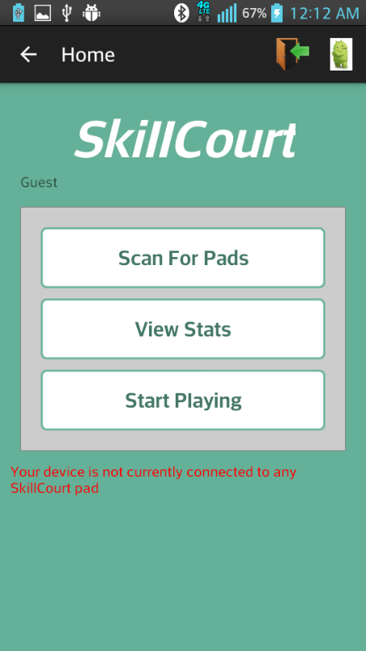

Step 1: Click the Logout icon on the top-left corner

### Routine Selection:

|  |  |
| --- | --- |
| At the end of this section, you will able to choose your desired SkillCourt routine and begin playing. | |
|  |  |
| Step 1: Click the “Start Playing” button on the SkillCourt Home Page | Step 2: Fill out the provided form to select routine to be played. Select routine type, difficulty level and adjust timer. |
|  |  |
| Step 3: The selected routine will load to the master pad and the simulator. Proceed to play. | Step 4: After the game is completed, a screen will appear on the application, showing the performance metrics. |

### Access Performance Statistics:

At the end of this section, you will be able to access your best performance metrics, as well as a series of graphs showing your progress through time.

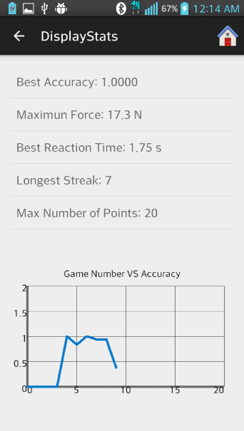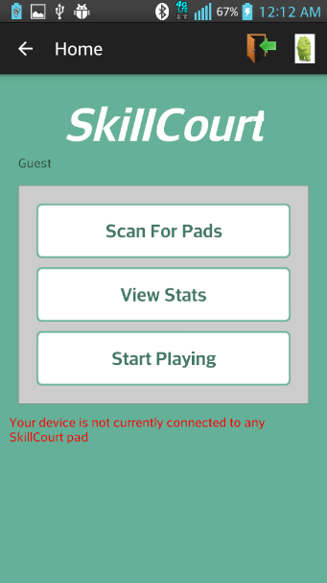

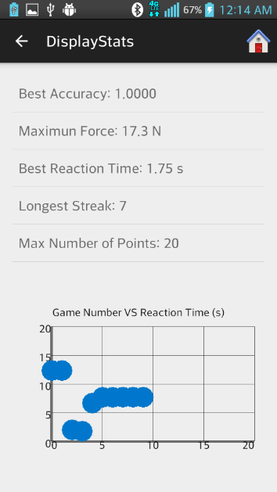Step 1: Click on the “View Stats” button on the Step 2: Click on the specific metric that you would like to see a line graph for.

Step 3: Click again on the same metrics to see a

scattered graph with all data points

## **Quick Reference**

* **What users can use the SkillCourt System?**

Any user that is interesting in improving their soccer skill. The SkillCourt system has been designed to be easy to use by everybody, and it has different difficulty levels, from novice to advanced, so it is fitted to all soccer enthusiasts.

* **Could SkillCourt be used for any sport other than Soccer?**

Yes. The idea is to create a system that can be used for a different variety of sports. However, so far, only soccer specific routines have been created.

* **Where can I download the SkillCourt Application?**

The application is not available yet. However, upon release, you will be able to download it from the Android Application Store

## **Accessing Online Help**

There is no current online help available.

## **References**